Make the Most of your Good Times

540 South Prospect Ave. * Hartville, Ohio 44632
www.hartvillerv.com
Akron/Canton: 330.877.3500 * Toll Free: 800.686.0201

WINTERIZING
(Steps 1-4)
- Empty all tanks (fresh water, gray water, sewage, water heater, shower pan and toilet).
- Open low point drains.
- Close low point drains.
- Blow air thru lines using an air hose and blow out plug.

Water Heater Bypass with Non-Toxic Anti-Freeze
( Steps 5-11)
- Turn off pump.
- Close valves A, B, and D. Open valves E and C. (refer to diagram below)
- Drain the water heater and fresh water tank.
- Put the hose from Valve E into a jug of Non-Toxic RV antifreeze.
(You will need more than one gallon of non-toxic RV antifreeze).
- Turn on the pump and open each faucet until the antifreeze flows through (including out-side shower). Do not forget to run the antifreeze through the toilet.
- Pour at least one cup of non-toxic RV antifreeze into each drain to protect the P-traps.
- Close Valve E.

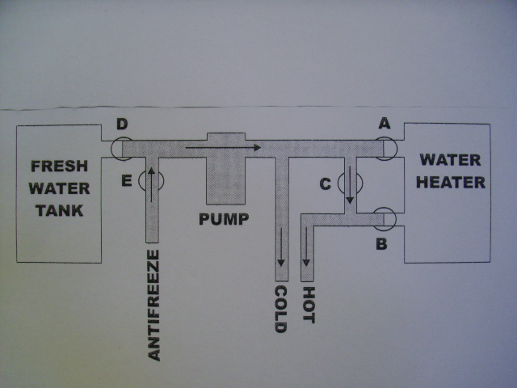
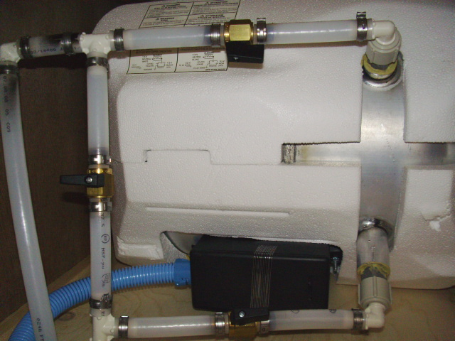
WATER HEATER BYPASS

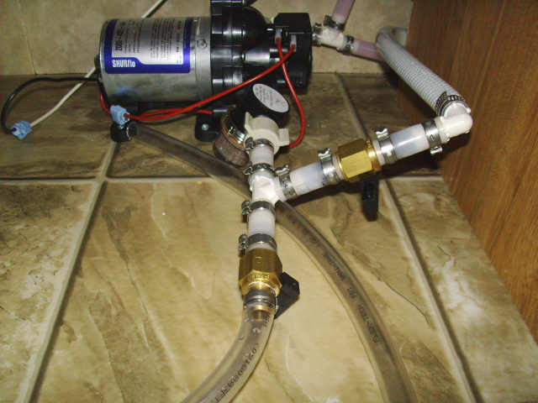
WATER PUMP

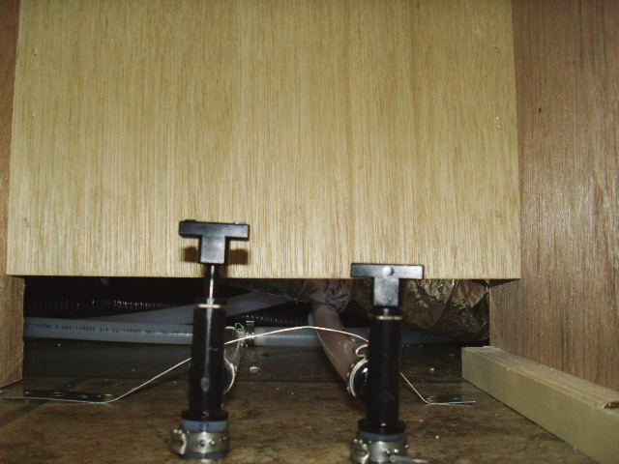
LOW POINT DRAINS

